**Requirement Document**

S3-CB04

Web Shop – “**S. H. A. I. N.”**



**Name :** Shanessa Kostaman (450080)

**Student Number :** 4082419

**Email :** genoveva.shanessakostaman@student.fontys.nl

**Teachers :**

Jacco Snoeren – [j.snoeren@fontys.nl](mailto:j.snoeren@fontys.nl)

Onno Marsman – [o.marsman@fontys.nl](mailto:o.marsman@fontys.nl)

**Fontys University of Applied Sciences**

**Eindhoven – Netherlands**

**2020-2021**

Table of Contents

Version Table 3

Introduction 4

Product Description 4

Product Backlog 5

User Story, Priority, Estimation, and Acceptance Criteria 5

Wireframe 8

ERD Diagram 9

# Version Table

I will provide historical data about each update that I made on the table below:

|  |  |  |
| --- | --- | --- |
| **Version** | **Date** | **Notes** |
| 1.0 | Thursday, 09 September 2021 | Start up with the introduction, product description, product backlog and priority, estimation, acceptance criteria, wireframe, ERD Diagram, and the version table. |
| 1.1 | Monday, 13 September 2021 | I did some changes with the Introduction, Product Description, User Story, the wireframe, and the ERD Diagram |
| 2.1 | Saturday, 25 September 2021 |  |

# Introduction

In this project I will make a clothing web shop. To make a clothing web shop there’s a lot of consideration because I have to do some survey about what do clothing web shop normally have on their website. I’ve got some ideas about how my website is going to looks like and I’m going to explain about it more detail on the product description.

# Product Description

This web application is about clothing web shop. It goes for women and man, on the web shop they can get a few kind of tops, a few kind of bottoms, and even a few kind of shoes. In the web shop it also provide accessories for the clothing and shoes. In this web shop it’s mandatory to become a member for the purchases, so if the user doesn’t have an account the can sign up to become one of the member, but if they do have the account they just have to sign in. There’s a lot of benefit becoming a member, because to have your own wish list user have to sign in so it’s indicate who’s the user.

# Product Backlog

## User Story, Priority, Estimation, and Acceptance Criteria

**Fibonacci range: 1-21 (For the estimation)**

|  |  |  |  |
| --- | --- | --- | --- |
| **No.** | **User Story** | **Priority** | **Estimation** |
| 1. | **As a** user **I can** add items to my cart **so that** I can buy the items later.  **Acceptance Criteria:**   * The selected item is added to the cart. | 1 | 8 |
| 2. | **As a** user **I can** add items to my whist list **so that** I can add items easily from my whist list to my cart.  **Acceptance Criteria:**   * The selected item is added to the wish list. | 8 | 13 |
| 3. | **As a** user **I want** to use search bar **so that** I can find the item that I’m looking for.  **Acceptance Criteria:**   * Products are filtered based on search. * Products that are out of stock are not displayed. | 9 | 5 |
| 4. | **As a** user **I can** edit the item’s size in my cart **so that** I can have different size from the previous item.  **Acceptance Criteria:**   * The newly chosen size overwrites previously chosen size. * If the item of that size is out of stock an error message is displayed. | 4 | 3 |
| 5. | **As a** user **I can** delete an item in my cart **so that** I can remove the item that I don’t want from my cart.  **Acceptance Criteria:**   * The item is removed from my cart. * The price of the total items is updated. | 2 | 3 |
| 6. | **As a** user **I can** edit the items quantity in my cart **so that** I can have different amount from the item.  **Acceptance Criteria:**   * The newly selected amount overwrites the previously selected amount. | 3 | 3 |
| 7. | **As a** user **I need** to sign-in or sign-up as a member **so that** I can access my purchase history  **Acceptance Criteria:**   * When registering the username and password of the created account are saved * When registering no 2 accounts with the same username can exist. * When logging in if the entered username and password is invalid an error message is displayed | 6 | 8 |
| 8. | **As a** user **I need** to fill in my delivery address details **so that** I can have my order delivered to me  **Acceptance Criteria:**   * The user data is saved for later use | 5 | 5 |
| 9. | **As a** user **I can** pay for my order so that I can receive my order  **Acceptance Criteria:**   * The payment is processed * If there is an error during the payment process the order is not shipped and an error message is displayed | 7 | 5 |
| 10. | **As a** User **I can** move the selected item from the cart to the wish list **so** the selected item will be removed from my cart and added to the wish list.  **Acceptance Criteria:**   * The selected item will be added to the wishlist and removed from the cart | 10 | 5 |
| 11. | **As an** Administrator **I have** to forward the order to the warehouse staff so the warehouse staff can prepare the orders  **Acceptance Criteria:**   * The warehouse staff will received the list of orders | 12 | 5 |
| 12. | **As an** Administrator **I can** see the list of order **so that** I can forward the orders to the warehouse staff.  **Acceptance Criteria:**   * The list of order will be shown. * The Admin can see the order number. | 11 | 5 |
| 13. | **As a** Warehouse staff **I can** see the order details from a specific order **so** I can prepare the order and send it to the customer.  **Acceptance Criteria:**   * The order is prepared and ready to ship | 13 | 3 |
| 14. | **As a** Warehouse Staff **I have to** send notification to the admin if the order has been sent **so** the admin can let the customer know that the product is on the way.  **Acceptance Criteria:**   * The Admin will send notification to the customer and customer receive the notification | 14 | 5 |
| 15. | **As an** Administrator **I have to** be able to receive the notification from the Warehouse Staff **so** I can send notification to the customer to let them know that the order is on the way.  **Acceptance Criteria:**   * The Customer receive the order | 15 | 5 |

# Wireframe

Checkout Process

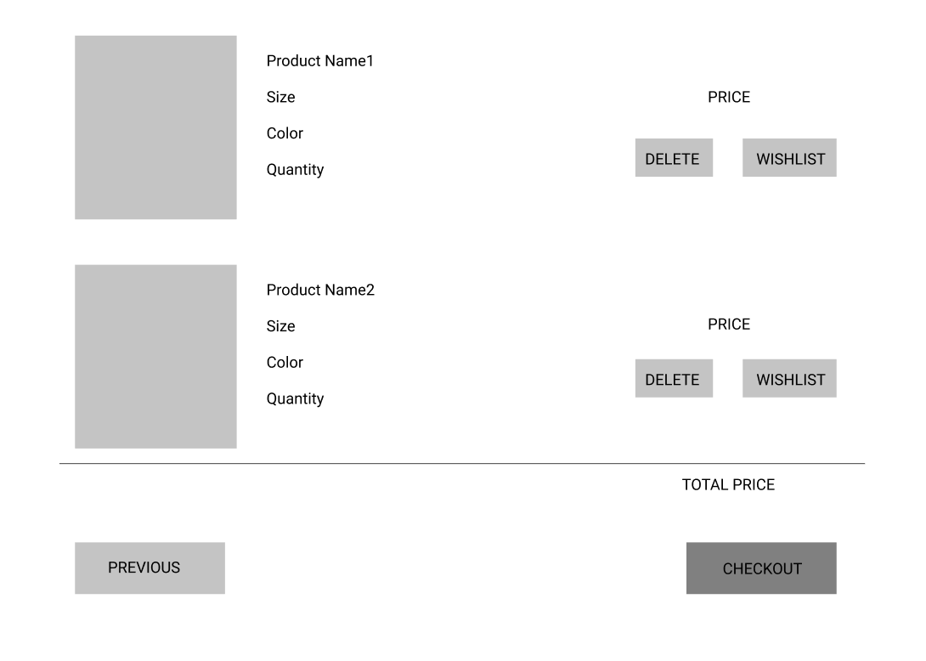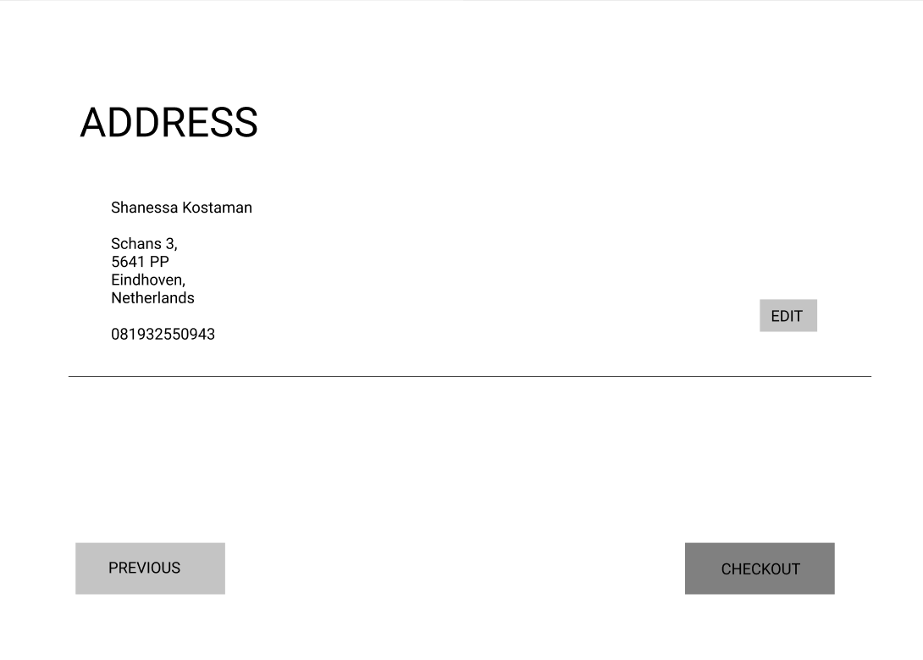

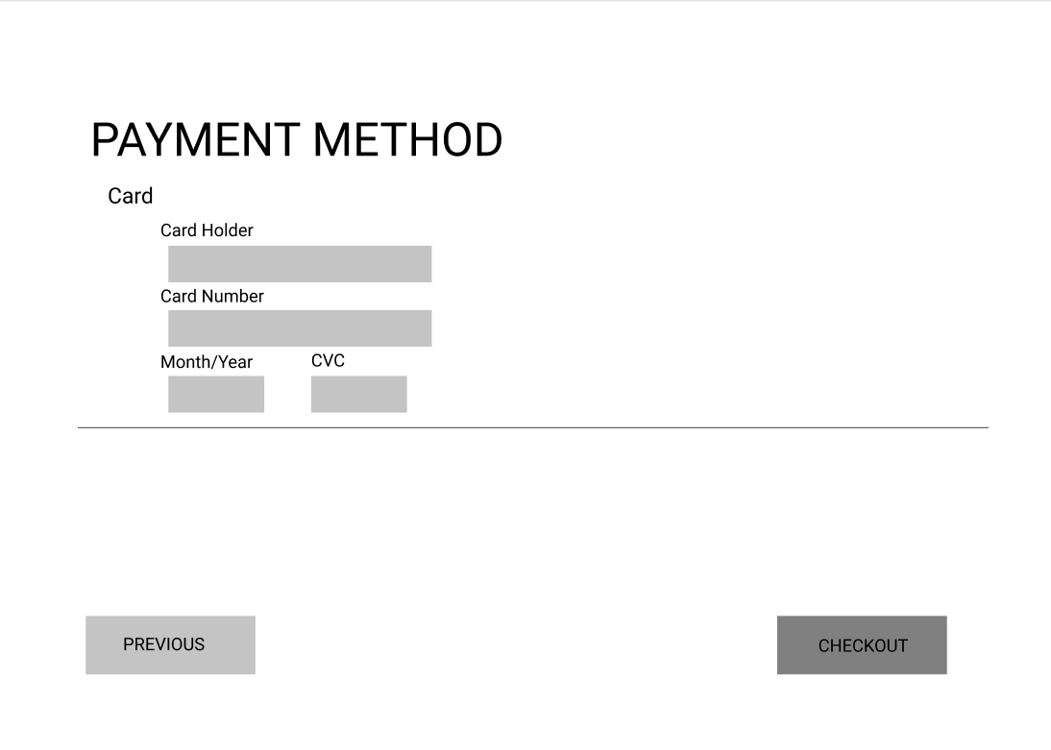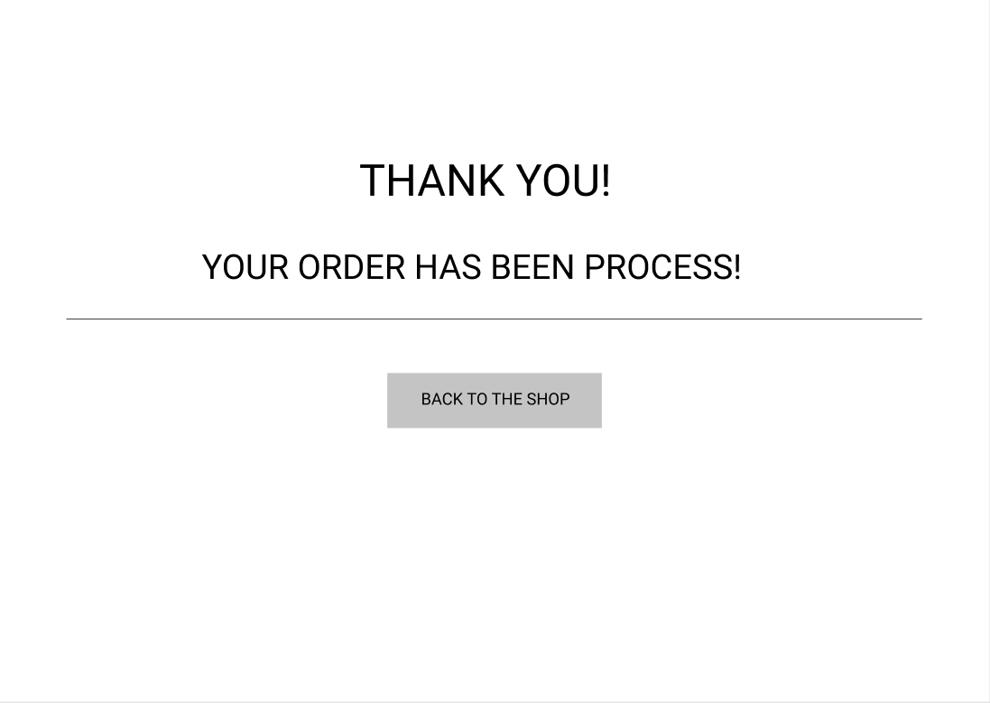

# ERD Diagram

